WEEK 1 INTERNSHIP REPORT
Data Acquisition, Cleaning and Exploratory Analysis of Student Academic Performance

Internship: Data Science with Python Internship

Dataset: Student Performance Dataset – Mathematics Course
INTRODUCTION:
Data preparation and exploratory data analysis are important stages in a data science project. Before developing statistical models or machine learning algorithms, the available data must be collected, examined, cleaned, and understood. The purpose of this project is to perform data acquisition, data cleaning, preprocessing, and exploratory data analysis using Python.
For this analysis, a publicly available Student Performance dataset was selected. The dataset contains information related to students' demographic background, family characteristics, school-related factors, study habits, and academic performance. The mathematics dataset was selected for the analysis, with the final grade (G3) being one of the important variables for understanding student academic performance.
Python libraries such as Pandas, Matplotlib, and Seaborn were used to load, inspect, clean, and visualize the dataset. The analysis focused on checking the quality of the data, identifying missing values and duplicate records, examining summary statistics, and exploring patterns through visualizations.

DATA ACQUISITION :
The dataset used for this project was the Student Performance dataset, which is publicly available for academic and research purposes. The dataset was downloaded in ZIP format and uploaded into the Google Colab environment. The uploaded file contained an additional ZIP archive, which was extracted to access the dataset files. The extracted dataset contained two main CSV files: student-mat.csv and student-por.csv, representing student performance in mathematics and Portuguese courses, respectively. For this project, student-mat.csv was selected because it provides detailed information about mathematics students and their academic performance.
The dataset was loaded into Python using the Pandas library. Since the file uses a semicolon as its delimiter instead of the standard comma, the sep=";" parameter was used while reading the CSV file.

Code snippet used for Data acquisition and loading:
import pandas as pd
df = pd.read_csv( "student_data/extracted/student-mat.csv", sep=";" )
df.head()

DATASET DESCRIPTION :
The selected dataset contains 395 student records and 33 variables. Each row represents one student, while the columns contain demographic, social, family, educational, and academic information.
The dataset includes variables such as age, sex, address, parental education, study time, previous academic failures, family relationships, free time, alcohol consumption, health status, absences, and academic grades. The variables G1, G2, and G3 represent student performance during the first grading period, second grading period, and final grading period respectively.
Both categorical and numerical variables are present in the dataset. Categorical variables include information such as school, sex, address, and parental job, while numerical variables include age, study time category, failures, absences, and grades.
Code snippet used for Data inspection:
print("Dataset shape:", df.shape)
print("Number of rows:", df.shape[0])
print("Number of columns:", df.shape[1])
print(df.columns.tolist())

DATA CLEANING AND PREPROCESSING :
Before performing exploratory analysis, the dataset was inspected to understand its structure and data quality. The info() function was used to examine the data types and the number of non-null values in each column. Missing values were checked using the Pandas isnull().sum() function. The inspection showed that there were no missing values in the selected dataset. Therefore, no imputation or removal of records was necessary.
Duplicate records were also checked using the duplicated() function. A cleaned copy of the original dataset was created, and duplicate rows were removed if present. The dataset retained its original structure after this verification process. The data types were also reviewed to ensure that numerical and categorical variables were appropriately represented. Since the existing data types were suitable for the analysis, unnecessary type conversion was avoided. This approach helped preserve the original meaning of the dataset while ensuring that it was ready for exploratory analysis.
Code snippet used to find duplicate and missing values:
missing_values = df.isnull().sum()
print(missing_values)
print("Total missing values:", missing_values.sum())
duplicate_rows = df.duplicated().sum()
print("Number of duplicate rows:", duplicate_rows)
The analysis identified 0 missing values and 0 duplicate rows in the dataset.
Code snippet used to create the Cleaned Dataset :
cleaned_df = df.copy()
cleaned_df = cleaned_df.drop_duplicates()
print("Cleaned dataset shape:", cleaned_df.shape)
A separate copy of the dataset was created for the cleaning process. Since no duplicate records were identified, the cleaned dataset retained all 395 records and 33 variables.

EXPLORATORY DATA ANALYSIS (EDA):
Exploratory Data Analysis (EDA) was performed to understand the characteristics, distributions, and relationships within the Student Performance dataset. Summary statistics were generated for the numerical variables to examine measures such as count, mean, standard deviation, minimum, maximum, and percentile values. The analysis particularly focused on variables related to academic performance, including age, study time, previous failures, absences, and the three grade variables: G1, G2, and G3. Visualizations were then created to explore the distribution of final grades, the relationship between study time and academic performance, correlations between numerical variables, and differences in final grades across study-time categories. These exploratory techniques helped identify important patterns and provided a foundation for the statistical analysis and machine learning tasks planned for the later stages of the project.
- SUMMARY STATISTICS
cleaned_df.describe()
The describe() function was used to generate summary statistics for the numerical variables. It provided information about the central tendency and spread of the data, including the mean, standard deviation, minimum and maximum values, and quartiles. These statistics helped provide an initial understanding of the variation in student characteristics and academic performance.

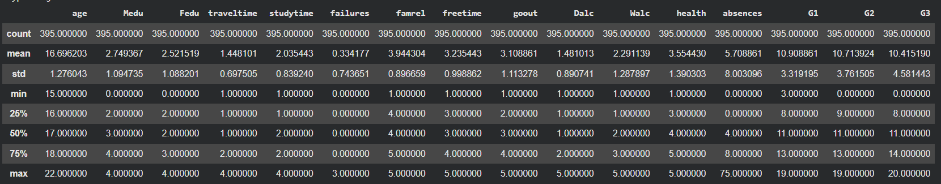
- VISUALIZATION 1: DISTRIBUTION OF FINAL GRADES

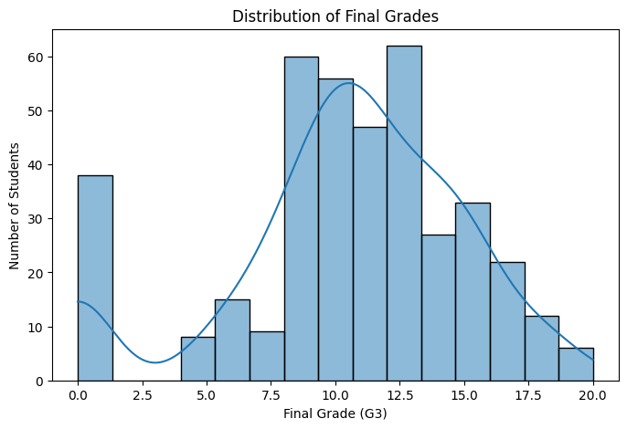
The histogram shows the distribution of students' final grades, which range from 0 to 20. Most student grades are concentrated in the middle range, particularly between approximately 8 and 15. A noticeable number of students have a final grade of zero, while comparatively fewer students achieved grades at the highest end of the scale. This indicates variation in academic performance and suggests that factors associated with lower performance can be investigated further.

Code snippet:
plt.figure(figsize=(8, 5))
sns.histplot(cleaned_df["G3"], bins=15, kde=True)
plt.title("Distribution of Final Grades")
plt.xlabel("Final Grade (G3)")
plt.ylabel("Number of Students")
plt.show()

- VISUALIZATION 2: STUDY TIME VS FINAL GRADE
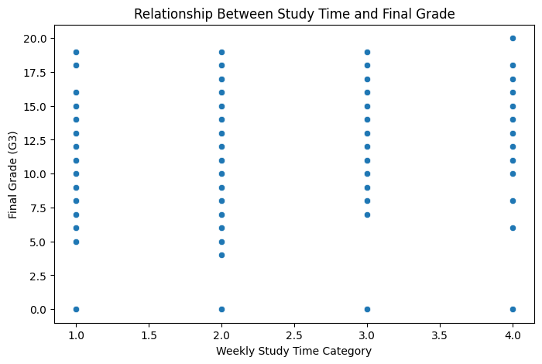
The scatter plot shows that students in all four study-time categories achieved a wide range of final grades. Although the higher study-time categories include several high-performing students, the points are widely distributed across all groups. Therefore, study time alone does not fully explain differences in final academic performance. Other factors, such as previous failures, absences, family background, and earlier academic performance, may also contribute to the final grade. In this dataset, the study-time variable represents four weekly study categories: less than 2 hours, 2 to 5 hours, 5 to 10 hours, and more than 10 hours.
Code snippet:
plt.figure(figsize=(8, 5))
sns.scatterplot(
data=cleaned_df,
x="studytime",
y="G3"
)
plt.title("Relationship Between Study Time and Final Grade")
plt.xlabel("Weekly Study Time Category")
plt.ylabel("Final Grade (G3)")
plt.show()

- VISUALIZATION 3: CORRELATION HEATMAP
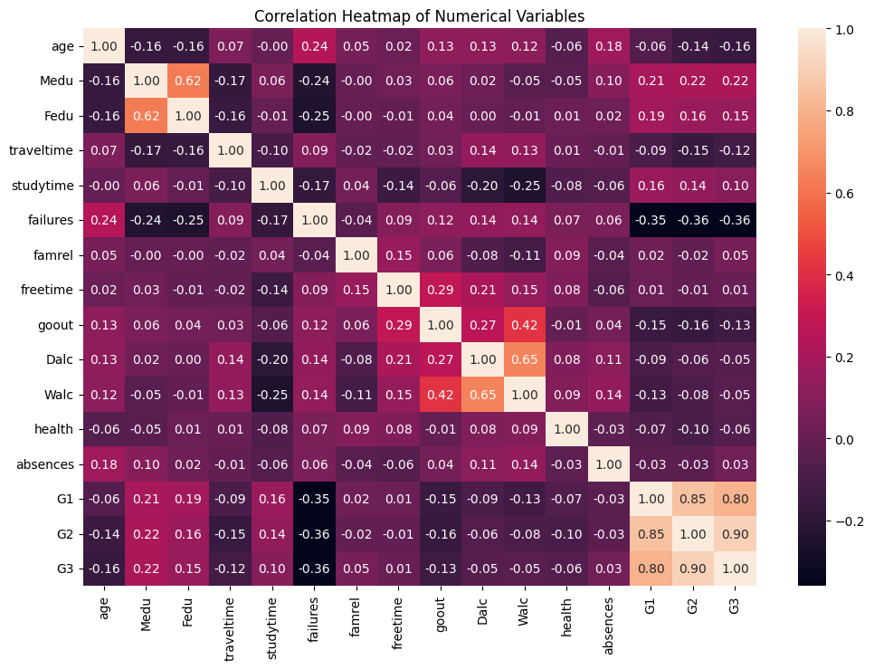
The correlation analysis revealed strong positive relationships between the three academic grade variables. The strongest positive correlation was observed between the second-period grade (G2) and final grade (G3), with a correlation value of approximately 0.90. The relationship between the first-period grade (G1) and final grade (G3) was also strong, with a value of approximately 0.80.Previous academic failures showed a moderate negative relationship with student grades. This suggests that students with a greater number of previous failures tend to have lower academic performance. The results indicate that earlier academic performance may be an important factor for understanding and predicting final student outcomes.
Code snippet:
numerical_columns = cleaned_df.select_dtypes(include=["int64", "float64"])

correlation_matrix = numerical_columns.corr()

plt.figure(figsize=(12, 8))

sns.heatmap(correlation_matrix, annot=True, fmt=".2f")

plt.title("Correlation Heatmap of Numerical Variables")

plt.show()

- VISUALIZATION 4: FINAL GRADE DISTRIBUTION BY STUDY TIME

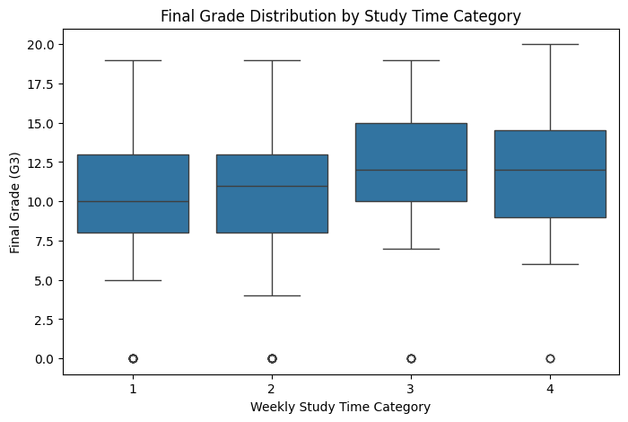
The box plot provides a clearer comparison of final grade distributions across the four study-time categories. Students in the higher study-time categories generally show slightly higher median final grades. However, there is considerable overlap between the grade distributions of all categories. This indicates that study time may be associated with academic performance, but it is not the only factor influencing final grades.Zero-grade values are present across the study-time categories, showing that low academic outcomes can occur regardless of the reported study-time group. Therefore, student performance should be examined using multiple factors rather than relying only on study time.
Code snippet:
plt.figure(figsize=(8, 5))
sns.boxplot(
data=cleaned_df,
x="studytime",
y="G3"
)
plt.title("Final Grade Distribution by Study Time Category")
plt.xlabel("Weekly Study Time Category")
plt.ylabel("Final Grade (G3)")
plt.show()
KEY FINDINGS:
The exploratory analysis of the Student Performance dataset produced several important findings:
- Data Quality: The dataset contained 395 student records and 33 variables. No missing values or duplicate records were identified, indicating that the dataset was already well structured for analysis.
- Final Grade Distribution: Most students' final grades were concentrated in the middle range, approximately between 8 and 15. A noticeable number of students had a final grade of zero, while very high grades were comparatively less common.
- Study Time and Performance: Students across all study-time categories showed a wide range of final grades. Although higher study-time groups included several high-performing students, study time alone did not completely explain academic performance.
- Previous Academic Performance: The correlation analysis showed strong positive relationships between G1, G2, and G3. In particular, G2 had a very strong positive correlation with the final grade, suggesting that earlier academic performance is closely associated with final outcomes.
- Previous Failures: The number of previous academic failures showed a moderate negative relationship with student grades, indicating that students with more previous failures generally tended to achieve lower grades.
CONCLUSION:
This project demonstrated the initial stages of a data science workflow, including data acquisition, inspection, cleaning, preprocessing, and exploratory data analysis. The Student Performance Mathematics dataset was successfully loaded and examined using Python and Pandas.
The data quality checks confirmed that the dataset contained no missing values and no duplicate records. Therefore, extensive cleaning or imputation was not required, and the original data structure was preserved for further analysis.
Exploratory analysis and visualizations provided useful insights into student academic performance. The analysis showed strong relationships between previous grading-period results and the final grade. Previous academic failures demonstrated a negative association with academic performance, while the relationship between study time and final grades showed considerable variation.
Overall, the findings suggest that student academic performance is influenced by multiple factors rather than a single variable. The cleaned dataset and insights obtained during this week provide a suitable foundation for the next stages of the project, including advanced data visualization, statistical hypothesis testing, and machine learning-based prediction.

